TOOLS AND EQUIPMENT NEEDED TO COMPLETE ONLINE AT HOME LABS
Approximate tools and equipment needed to complete your labs. This list may vary with what you decide to do and with what you have available. Please talk to your instructors if you have any questions or concerns

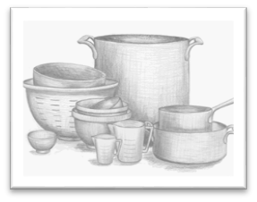
Required
- Sturdy cutting board, preferably wooden or thick plastic
- Chef’s knife or French knife
- Vegetable peeler
- Paring knife
- Serrated knife
- Colander
- Fine mesh strainer
- Ladle
- Wisk
- Heat resistant cooking spoons
- Tongs
- Flat spatula
- Rubber spatula
- 2-3 mixing bowls
- At least one 2-quart saucepot or saucepan or larger
- Measuring cups
- Measuring spoons
- Large Frypan or sauté pan
- Small fry pan or sauté pan
- 2 cookie sheets or sheet pans
- Roasting or baking pan
- Stovetop with burners
- A toaster or the broiler function in your oven
- An oven
- A butter knife
- A tablespoon or two
- Round cookie cutter for biscuits
- Muffin pan
- Food storage containers for holding your prepped food and ingredients
- Plates, bowls, etc. for serving and presenting your final products

Optional but not required
- Citrus zester
- Sharpening steel
- Blender or stick blender
- Rolling pin
- Pizza cutter
- Pastry brush
- Box grater/ cheese grater
- Mini fryer or a pot to fry in
- Grill or broiler
- Sifter

